NORDPSO

Strategy Paper
2020-ff
Last update April, 2021
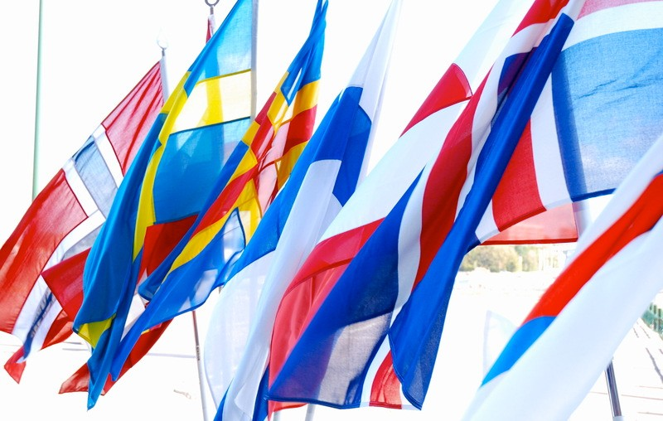

About NORDPSO
NORDPSO is an association for cooperation between the psoriasis associations in the Nordic countries and was founded in 1986.
The association is politically and religiously neutral. NORDPSO consists of the top management of a Psoriasis Association from each member country.
NORDPSO aims to be a common voice on issues concerning psoriatic disease throughout the Nordic region.

About Psoriatic Disease
Psoriasis is an immune-mediated disease (a disease with an unclear cause that is characterized by inflammation caused by dysfunction of the immune system) that causes inflammation in the body. There may be visible signs of the inflammation such as raised plaques (plaques may look different for different skin types) and scales on the skin.
Inflammation caused by psoriasis can impact other organs and tissues in the body. People with psoriasis may also experience other health conditions. One in three people with psoriasis may also develop psoriatic arthritis.
Symptoms often start between ages 15 and 25, but can start at any age. Men, women, and children of all skin colors can get psoriasis.

Organization
NORDPSO's highest decision-making body is the Council Meeting (held every 2nd year). Between these meetings, the business is run by a Board (twice a year).
The chairmanship of the Board alternates between the member countries according to a plan. The meetings alternate between the countries and the country in which a meeting is held is the host country.

Date | Meeting | Chair | Host country | Notes
2019 |  |  |  | Updated 211115
Apr 2019 | Council | Norway | Faroe Islands | Cancelled due to air traffic strike
Jun 2019 | Board | Norway | Digital
Nov 2019 | Council | Norway | Sweden
Nov 2019 | Board | Sweden | Sweden
2020
Apr 2020 | Board | Sweden | Denmark | Cancelled due to covid19
Nov 2020 | Board | Sweden | Digital
2021
Apr 2021 | Council | Sweden | Digital
Apr 2021 | Board | Denmark | Digital
Nov 2021 | Board | Denmark | Denmark
2022
Apr 2022 | Board | Denmark | Digital
Nov 2022 | Board | Denmark | Iceland
2023
Apr 2023 | Council | Denmark | Faraoe Islands
Apr 2023 | Board | Finland | Faraoe Islands
Nov 2023 | Board | Finland | Digital
2024
Apr 2024 | Board | Finland | Finland
Nov 2024 | Board | Finland | Digital
2025
Apr 2025 | Council | Finland | Norway
Apr 2025 | Board | Iceland | Norway
Nov 2025 | Board | Iceland | Digital
2026
Apr 2026 | Board | Iceland | Sverige
Nov 2026 | Board | Iceland | Digital
2027
Apr 2027 | Council | Iceland | Sverige

Organization

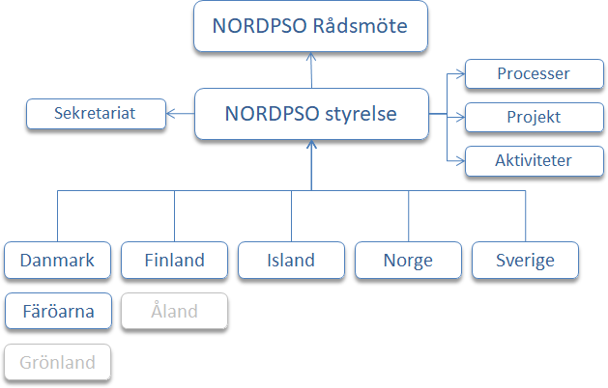

The business rests on three pillars
- Joint processes
- Joint projects
- Joint activities

Joint processes refers to the association's strategies, knowledge-raising measures and exchange of experience. This also includes support for the development of the organizations in each country, for example method support, tip catalog, etc.

Activities refer to meetings, conferences or other events, such as the Board, participation in other meetings or conferences on behalf of NORDPSO, etc.

Projects refer to targeted joint initiatives or initiatives to areas that are best run in project form, for example research projects, development projects, etc.

NORDPSO can form working groups or project groups. However, NORDPSO's Board of Directors is responsible for decisions. The groups can only submit proposals to the board, unless otherwise agreed.

The entire operation is the basis for applying for funding from, for example, the Nordic Welfare Center.

Vision
Each member state of NORDPSO has its own vision, goal or mission.
NORDPSO's common vision reads:

Kompletteras

Denmark

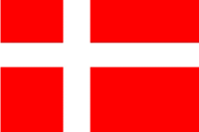

Vision
”Et liv uden psoriasis”

Mission
”At kæmpe for bedre vilkår og livskvalitet for mennesker med psoriasis i hud og led og deres pårørende”

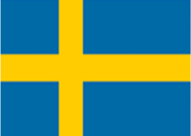
Sweden

Vision
”Ett bra liv för alla med psoriasis och psoriasisartrit”

Mission
”Att verka för goda livsvillkor för människor med psoriasis, bättre stöd åt alla psoriasissjuka, verka för upplysning och forskning och för bättre vård-, behandlings- och arbetsmöjligheter” (förkortad version)

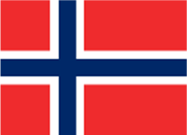
Norway

Vision
Kompletteras

Mission
Kompletteras

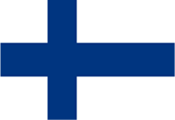
Finland

Vision
Kompletteras

Mission
Kompletteras

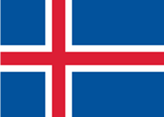
Iceland

Vision
Kompletteras

Mission
Kompletteras

Färöarna
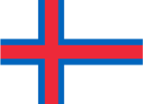
Vision
Kompletteras

Mission
Kompletteras

Mission
In collaboration between the member states, improve care, treatment and work opportunities for all psoriasis patients; to ensure that psoriasis patients are provided with the same economic, social and cultural standard as other citizens in the Nordic countries and to work for information and research in psoriasis.

Values that unite
There are values that unite the member countries of the association NORDPSO.

- Democracy
- Gender equality
- Reliability

Member States also have other factors that unite:
- Nordic welfare systems and good public health care
- Nordic climate
- Prevalence of psoriasis
- Professional organizations
- High membership
- Individual perspective, the best interests of individuals
- Our interest and in our role as a party in other organizations for psoriasis, such as The International Federation of Psoriasis Associations (IFPA).

NORDPSO is an independent organization that is independent of the pharmaceutical industry.

Goals and Direction
The goals and direction are defined at each Council meeting and updated in this Strategy Paper.
- A joint process on the theme of the future. The process must be about structural issues that concern our associations' organization or challenges (eg membership, generational change, development of healthcare, changes in the business environment, etc.). The process can take place in connection with and between the biannual Board meetings and can also take place in a project group
  - Expected results: Exchange of experience, build a common documented experience bank with a catalog of ideas that can be shared between the countries and continuously updated. The experience bank can consist of status reports, a summary of strategic discussions, etc. The idea catalog can consist of concrete ideas from the member countries, such as information material, campaign material, publications, etc.
- Joint activities in the form of the Council and the Board. The activities are organized according to the meeting schedule.
  - Expected result: One Council meeting every 2nd year, and two Board per year.

- A project within climate care. The project will summarize the knowledge or results that are documented about climate care and create a more comprehensive knowledge base. Furthermore, the project will organize a Nordic conference on climate care. The process can take place in connection with and between the Boards and can also take place in a project group.
  - Expected result: At least one common knowledge base / document that can be disseminated to decision-makers. A joint advocacy conference aimed at the countries' decision-makers.

- At least one joint project for youth activities. The project will build on the action plan developed in 2017 in Helsinki. The project is carried out within the framework of a special project organization.
  - Expected results: At least one proposal for continued organization of youth activities, at least one meeting among the representatives appointed by the countries (further results can be supplemented later).

Statues and Plans
NORDPSO has its own statutes and develops a time- and business plan.

Financing
NORDPSO finances its activities with its own funds and with support from the Nordic Council of Ministers via the Nordic Welfare Center.

Scientific Projects, research results and initiatives
NORDPSO supports and monitors scientific projects and scientific research results regarding psoriasis and psoriasis-related disease. Where applicable, in connection with Council or
Board, researchers or others are invited as lecturers. Over the years, special symposia have also been organized.

Examples of initiatives within NORDPSO:

- Psoriatic Arthritis Mutilans (PAM) in the Nordic countries - completed in 2019. The Nordic PAM group was formed to specifically study the incidence and clinic of the rare mutilating variant of psoriatic arthritis in a collaborative project between interested dermatologists and rheumatologists and NORDPSO.
- Quality of life in Nordic Patients with Psoriasis: The NORDPSO Study (2001-2004). The survey on quality of life was important for NORDPSO's member organizations. For the first time, comprehensive research information was given on the situation in psoriasis care, the severity of the disease, the quality of life, etc.
Significant was the information about the occurrence of psoriatic arthritis that turned out to be more common than previously known.
- Climate care. Of all forms of treatment, climate care has long been the sub-area for which NORDPSO has worked. Among other things, the issue has been up in the Nordic Council of Ministers regarding a pan-Nordic climate care practice (1987). Nordic consensus was not reached in the Council because the countries were of different views. In the early 1990s, NORDPSO's board discussed the possible purchase of a joint treatment plant on Lanzarote, but it was found to be too expensive. More examples are available.
The climate care issue is still relevant on NORDPSO's agenda.
- Working Group on Psoriatic Arthritis (PsA) (2001-nn). For several years, NORDPSO has had a working group that looked more closely at joint initiatives to put increased focus on psoriatic arthritis.

